**SOMAIYA** 

**V I D Y A V I H A R**



**K J Somaiya Institute of Technology**

**An Autonomous Institute Permanently Affiliated to the University of Mumbai**

**DEPARTMENT OF INFORMATION TECHNOLOGY**

**Course Name and Code:** Data Structures Lab **(**ITL302)

**Semester:** III (SYIT)

**Academic Year:** 2024-25 (Odd Semester)

**Experiment No. 08**

**Aim:** Implementation of any one Sorting Technique for rea1-world application .

**Code:** 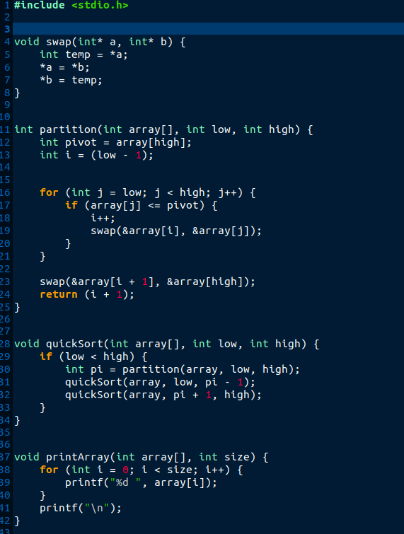

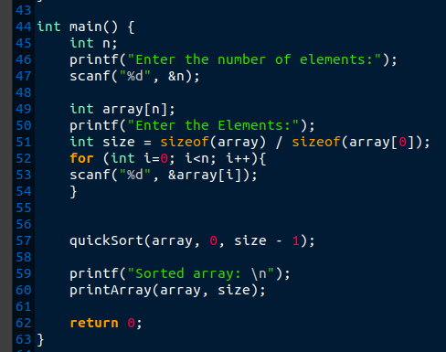

**Output :**

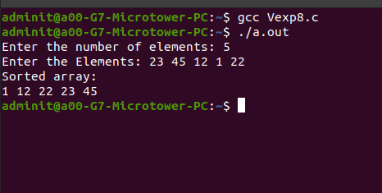

**Submitter Details:-**

**Name:** Veer Gokani

**Roll No:** 30

**Div/Batch :** A/ S-2

**Date of submission :** 20/09/2024